NIP Cheatsheet

● Vectors (Dynamic Arrays) 1
● Set 2
● Stack 2
● Queue 2
● Priority Queue (Max/Min Heap) 2
● String Functions (in #include <string>) 3
● Algorithms (in #include <algorithm>) 4
● Bit Manipulation (in #include <bitset> and built-in functions) 4
● Unordered Maps (in #include <unordered_map>) 5
● LinkedLists: 7
● Heap Functions (Priority Queue) 8
● Heap Utility Functions (<algorithm>) 9
● Explanation of Heaps 9

● Vectors (Dynamic Arrays)
// Basic Operations
vector<int> v;
v.push_back(value); // void: Adds an element at the end
v.pop_back(); // void: Removes the last element
v.clear(); // void: Removes all elements
v.reserve(n); // void: Reserves space for at least n elements
v.resize(new_size); // void: Resizes to new_size
v.size(); // size_t: Returns the size
v.empty(); // bool: Returns true if empty
v.at(index); // int&: Returns element at index
v.front(); // int&: Returns first element
v.back(); // int&: Returns last element

// Iterator Operations
v.begin(); // iterator: Returns iterator to first element
v.end(); // iterator: Returns iterator to past-the-end element

// Insertion and Erasure
v.insert(v.begin() + index, value); // iterator: Inserts value at index
v.erase(v.begin() + index); // iterator: Removes element at index
v.emplace_back(value); // void: Constructs element in-place at end
v.emplace(v.begin() + index, value); // void: Constructs element in-place at index

// Sorting and Manipulating
sort(v.begin(), v.end()); // void: Sorts in ascending order
reverse(v.begin(), v.end()); // void: Reverses the order of elements
rotate(v.begin(), v.begin() + n, v.end()); // void: Rotates by n positions
unique(v.begin(), v.end()); // iterator: Removes consecutive duplicates

// Searching and Counting
find(v.begin(), v.end(), value); // iterator: Returns iterator to first occurrence
count(v.begin(), v.end(), value); // int: Returns number of occurrences
binary_search(v.begin(), v.end(), value); // bool: Returns true if present (sorted vector)

Use case: Vectors are useful when you need a dynamically resizable array. You can perform operations like insertion, deletion, sorting, and reversing efficiently. They're heavily used in competitive programming due to ease of use and STL functions.

● Set
// Set
std::set<int> s;

// Basic Operations
s.insert(10); // pair<iterator, bool>: Inserts an element (unique)
s.erase(10); // size_t: Erases element, returns number of elements removed
s.find(10); // iterator: Returns iterator to element or s.end() if not found
s.count(10); // size_t: Returns 1 if element exists, 0 otherwise
s.size(); // size_t: Returns number of elements in the set
s.empty(); // bool: Checks if the set is empty

// Traversal
s.begin(); // iterator: Iterator to the first element
s.end(); // iterator: Iterator to element after the last
s.rbegin(); // reverse_iterator: Iterator to the last element (reverse traversal)
s.rend(); // reverse_iterator: Iterator to one before the first (reverse traversal)
s.cbegin(); // const_iterator: Const iterators for read-only traversal
s.cend(); // const_iterator: Const iterators for read-only traversal

// Range Queries
s.lower_bound(10); // iterator: Iterator to the first element >= 10
s.upper_bound(10); // iterator: Iterator to the first element > 10

// Modifiers
s.clear(); // void: Removes all elements from the set
s.swap(another_set);// void: Swaps the contents of two sets

// Other Functions
s.equal_range(10); // pair<iterator, iterator>: Returns a range of elements equivalent to 10 (for set, always a single element or s.end())
s.key_comp(); // comparison object: Returns the comparison object used for ordering elements
s.value_comp(); // comparison object: Returns the comparison object used for ordering elements

// Use Case
// Sets store unique elements in sorted order and allow fast insertion, deletion, and lookup in O(log n).
// Ideal for:
// - Storing distinct elements.
// - Solving problems requiring quick search, like finding the smallest/largest element.
// - Efficient range queries using lower_bound or upper_bound.

● Unordered Set
std::unordered_set<int> us;

// Basic Operations
us.insert(10); // pair<iterator, bool>: Inserts an element (unique)
us.erase(10); // size_t: Erases element, returns number of elements removed
us.find(10); // iterator: Returns iterator to element or us.end() if not found
us.count(10); // size_t: Returns 1 if element exists, 0 otherwise
us.size(); // size_t: Returns number of elements in the set
us.empty(); // bool: Checks if the set is empty

// Traversal
us.begin(); // iterator: Iterator to the first element
us.end(); // iterator: Iterator to element after the last
us.cbegin(); // const_iterator: Const iterators for read-only traversal
us.cend(); // const_iterator: Const iterators for read-only traversal

// Modifiers
us.clear(); // void: Removes all elements from the set
us.swap(another_unordered_set); // void: Swaps the contents of two unordered sets

// Hash Table-Specific Functions
us.bucket_count(); // size_t: Returns the number of buckets in the hash table
us.bucket_size(index); // size_t: Returns the number of elements in the bucket at index
us.bucket(key); // size_t: Returns the bucket number where key is stored
us.load_factor(); // float: Returns the average number of elements per bucket
us.max_load_factor(); // float: Returns or sets the maximum load factor
us.rehash(new_bucket_count); // void: Reorganizes the hash table with at least new_bucket_count buckets
us.reserve(size); // void: Reserves enough buckets to hold size elements without rehashing

// Use Case
// Unordered sets store unique elements in no specific order and allow very fast insertion, deletion, and lookup in O(1) on average (worst-case O(n) due to hash collisions).
// Ideal for:
// - Large datasets where order doesn’t matter.
// - Frequent insertions/deletions.

● Stack

stack<int> st;
st.push(10); // void: Inserts an element at the top
st.pop(); // void: Removes the top element
st.top(); // int&: Returns reference to the top element
st.empty(); // bool: Returns true if the stack is empty
st.size(); // size_t: Returns the size of the stack

Use case: Stacks follow LIFO (Last In, First Out) order and are useful in problems involving recursion, parentheses balancing, or depth-first search (DFS).

● Queue
queue<int> q;
q.push(10); // void: Inserts an element at the back
q.pop(); // void: Removes the front element
q.front(); // int&: Returns reference to the front element
q.back(); // int&: Returns reference to the last element
q.empty(); // bool: Returns true if the queue is empty
q.size(); // size_t: Returns the size of the queue

Use case: Queues follow FIFO (First In, First Out) order and are used in problems involving breadth-first search (BFS), task scheduling, or simple simulations.

● Priority Queue (Max/Min Heap)
priority_queue<int> pq; // Max-heap by default
priority_queue<int, vector<int>, greater<int>> pq_min; // Min-heap
pq.push(10); // void: Inserts an element
pq.pop(); // void: Removes the top element
pq.top(); // const int&: Returns reference to the top element (max/min)
pq.empty(); // bool: Returns true if the queue is empty
pq.size(); // size_t: Returns the size of the queue

Use case: Priority queues allow efficient retrieval of the largest or smallest element and are often used in graph algorithms (e.g., Dijkstra's), task scheduling, and finding the k-th largest element.

● String Functions (in #include <string>)
string s = "example";

Basic Functions:
s.length(); // size_t: Returns the length of the string
s.size(); // size_t: Alias for length()
s.empty(); // bool: Returns true if the string is empty
s.clear(); // void: Clears the string (sets it to an empty string)
s.append("test"); // string&: Appends "test" to the end of the string
s += "test"; // string&: Concatenates "test" to the string
s.compare("test"); // int: Lexicographically compares s with "test" (-1 if less, 0 if equal, 1 if greater)
s.find("amp"); // size_t: Returns the starting index of "amp", or string::npos if not found
s.rfind("e"); // size_t: Returns the last occurrence of 'e' (reverse find)
s.substr(2, 4); // string: Returns substring starting at index 2 of length 4
s.insert(3, "test"); // string&: Inserts "test" at index 3
s.erase(1, 2); // string&: Erases 2 characters starting at index 1
s.replace(1, 3, "new"); // string&: Replaces 3 characters starting at index 1 with "new"
s.front(); // char&: Returns the first character
s.back(); // char&: Returns the last character
s.at(2); // char&: Returns the character at index 2 (bounds-checked)
s.c_str(); // const char*: Returns C-string equivalent (useful for legacy functions)

Advanced String Manipulation:
string::npos; // Constant for representing invalid positions in string (e.g., find() not found)
transform(s.begin(), s.end(), s.begin(), ::toupper); // void: Converts string to uppercase (requires #include <algorithm>)
transform(s.begin(), s.end(), s.begin(), ::tolower); // void: Converts string to lowercase

// Read words separated by spaces
while (std::getline(std::cin, str, ' ')) {
words.push_back(str);
}

// Sort each word lexicographically
for (auto& word : words) {
std::sort(word.begin(), word.end()); // Sort the characters of each word
}

● Algorithms (in #include <algorithm>)
vector<int> v = {1, 5, 2, 9};

Sorting and Searching:
sort(v.begin(), v.end()); // void: Sorts the vector in ascending order (O(n log n))
sort(v.begin(), v.end(), greater<int>()); // void: Sorts the vector in descending order
stable_sort(v.begin(), v.end()); // void: Stable sort (maintains relative order of equal elements)
partial_sort(v.begin(), v.begin() + k, v.end()); // void: Partially sorts the first k elements
binary_search(v.begin(), v.end(), 5); // bool: Checks if 5 exists in the sorted vector (O(log n))
lower_bound(v.begin(), v.end(), 5); // iterator: Returns iterator to first element >= 5
upper_bound(v.begin(), v.end(), 5); // iterator: Returns iterator to first element > 5

Permutations:
next_permutation(v.begin(), v.end()); // bool: Generates the next lexicographical permutation
prev_permutation(v.begin(), v.end()); // bool: Generates the previous lexicographical permutation

Min/Max and Miscellaneous:
max_element(v.begin(), v.end()); // iterator: Returns iterator to the max element
min_element(v.begin(), v.end()); // iterator: Returns iterator to the min element
reverse(v.begin(), v.end()); // void: Reverses the vector
rotate(v.begin(), v.begin() + k, v.end()); // void: Rotates the vector so the k-th element becomes the first
count(v.begin(), v.end(), 5); // size_t: Counts the number of occurrences of 5 in the range
find(v.begin(), v.end(), 5); // iterator: Returns iterator to first occurrence of 5, or v.end() if not found
unique(v.begin(), v.end()); // iterator: Removes consecutive duplicates (doesn't change size)
accumulate(v.begin(), v.end(), 0); // int: Sums all elements in the vector (requires #include <numeric>)

Use cases: Algorithm functions are critical for efficient sorting, searching, and manipulating sequences. Functions like binary_search, sort, next_permutation, and count often solve competitive programming tasks in minimal lines of code.

● Bit Manipulation (in #include <bitset> and built-in functions)
int x = 29; // Binary: 11101

Basic Bit Manipulation:
x & (1 << n); // int: Checks if the n-th bit is set (1-based indexing)
x | (1 << n); // int: Sets the n-th bit to 1
x & ~(1 << n); // int: Clears (sets to 0) the n-th bit
x ^ (1 << n); // int: Toggles the n-th bit
x >> n; // int: Right shifts by n bits (divides by 2^n)
x << n; // int: Left shifts by n bits (multiplies by 2^n)
x & (x - 1); // int: Clears the lowest set bit
x & (-x); // int: Isolates the lowest set bit
~x; // int: Bitwise NOT (flips all bits)
x ^ y; // int: Bitwise XOR (sets bits that differ in x and y)
x | y; // int: Bitwise OR (sets bits where either x or y has a 1)
x & y; // int: Bitwise AND (sets bits where both x and y have 1)
x == 0 ? 0 : 31 - __builtin_clz(x); // int: Position of the highest set bit (1-based, GCC/Clang)

Built-in Functions:
__builtin_popcount(x); // int: Returns the number of set bits (1s) in x
__builtin_clz(x); // int: Counts leading zeros (for non-negative integers)
__builtin_ctz(x); // int: Counts trailing zeros (zeros at the end of binary representation)
__builtin_parity(x); // int: Returns 1 if the number of set bits is odd, otherwise 0

Bitset (for handling fixed-size bit arrays):
bitset<8> b(29); // 8-bit representation of 29 -> 00011101
b.count(); // int: Returns the number of set bits (1s)
b.set(); // bitset&: Sets all bits to 1
b.reset(); // bitset&: Sets all bits to 0
b.flip(); // bitset&: Flips all bits
b.test(2); // bool: Checks if the 2nd bit is set

Use cases: Bit manipulation is used to solve problems involving subsets, masks, and fast multiplication/division by powers of 2. Functions like __builtin_popcount and shifting are useful in combinatorics, bitmask DP, and problems where space and time efficiency are important.

● Unordered Maps (in #include <unordered_map>)
unordered_map<string, int> umap;

Basic Operations:
umap["key"] = 10; // int&: Inserts or updates the value for "key"
umap.at("key"); // int&: Returns the value associated with "key" (throws exception if key not found)
umap.size(); // size_t: Returns the number of key-value pairs
umap.empty(); // bool: Returns true if the map is empty
umap.erase("key"); // size_t: Erases the key-value pair (returns number of elements erased)
umap.find("key"); // iterator: Returns iterator to the key or umap.end() if not found
umap.count("key"); // size_t: Returns 1 if key exists, 0 otherwise
umap.clear(); // void: Clears the map

Iteration:
for (auto &p : umap) {
cout << p.first << " -> " << p.second << endl; // Iterating over key-value pairs
}

Bucket Information:
umap.bucket_count(); // size_t: Returns the number of buckets in the hash table
umap.load_factor(); // float: Returns the load factor (size / bucket count)
umap.max_load_factor(1.0); // void: Sets maximum load factor before rehashing
umap.rehash(20); // void: Rehashes the table to have at least 20 buckets

Use cases: unordered_map is an efficient hash table with O(1)O(1)O(1) average time complexity for insertions, deletions, and lookups. It's used when you don't need the elements sorted, like in frequency counting or when fast access to values is crucial.

Frequency Counting
unordered_map<int, int> freq;
for (int i = 0; i < n; i++) freq[arr[i]]++;
// freq[x] gives count of element x

Check If Key Exists
if (umap.find(key) != umap.end()) {
// Key exists, use umap[key]
} else {
// Key does not exist
}

Erasing Elements
umap.erase(key); // Removes key-value pair if key exists

Inserting a Key-Value Pair
umap[key] = value; // Inserts or updates the value for the key

Get Value for a Key
int val = umap[key]; // Access value; 0 if key doesn't exist (for int)

Iterate Over Map
for (auto it = umap.begin(); it != umap.end(); it++) {
cout << it->first << " -> " << it->second << endl;
}

Count Occurrences of Key
if (umap.count(key)) {
// Key exists (returns 1)
} else {
// Key does not exist (returns 0)
}

Clearing the Map
umap.clear(); // Removes all key-value pairs

Size of the Map
int size = umap.size(); // Returns the number of key-value pairs

Find Key with Default Value (Pattern)
int val = umap.count(key) ? umap[key] : default_value;

● LinkedLists:

1. Merge Two Sorted Linked Lists
● Logic: Compare the heads of both lists, and append the smaller node to the new list. Recursively do this until all nodes are merged.
2. Detect Cycle and Find Start of Cycle
● Logic: Use two pointers (slow and fast). If they meet, there's a cycle. Move one pointer to the head and the other at the meeting point; the point they meet next is the cycle start.
3. Remove N-th Node from End
● Logic: Use a dummy node. Move a pointer n steps ahead. Move both pointers until the first reaches the end; the second will be before the node to remove. Adjust pointers to skip the node.
4. Find Intersection of Two Linked Lists
● Logic: Use two pointers. Traverse both lists; when one pointer reaches the end, switch to the other list. They will meet at the intersection or both will be null.
5. Reorder List
● Logic: Split the list in half, reverse the second half, and then merge the two halves back together, alternating nodes from each half.
6. Flatten a Multilevel Doubly Linked List
● Logic: Traverse the list and for each node, if it has a child, recursively flatten the child list and append it to the main list, adjusting pointers.
7. Clone a Linked List with Random Pointer
● Logic: Create a mapping of original nodes to cloned nodes. For each original node, set the next and random pointers in the cloned nodes based on the mapping.
8. K-th Node from End
● Logic: Use two pointers. Move one pointer k steps ahead, then move both pointers until the first reaches the end. The second pointer will be at the k-th node from the end.
9. Palindrome Linked List
● Logic: Find the middle of the list. Reverse the second half and compare it with the first half for equality.
10. Swap Nodes in Pairs
● Logic: Traverse the list in pairs and adjust pointers to swap each pair of nodes, linking the swapped pairs correctly.

● Heap Functions (Priority Queue)

Max-Heap (Default Behavior of priority_queue)
priority_queue<int> pq;
pq.push(value); // void: Inserts value into the heap
pq.pop(); // void: Removes the largest (top) element
pq.top(); // int: Returns the largest element
pq.empty(); // bool: Returns true if the heap is empty
pq.size(); // size_t: Returns the number of elements

Working:
○ A max-heap is a binary tree where each parent node is greater than its children.
○ The largest element is always at the top.
○ push() inserts elements and ensures the heap property is maintained.
○ pop() removes the top (largest) element and rearranges the heap.
○ Time Complexity: push() and pop() take O(log n) time because after insertion/deletion, the heap may need reordering.

Min-Heap (Using priority_queue with Custom Comparator)
priority_queue<int, vector<int>, greater<int>> pq;
pq.push(value); // void: Inserts value into the min-heap
pq.pop(); // void: Removes the smallest (top) element
pq.top(); // int: Returns the smallest element
pq.empty(); // bool: Returns true if the heap is empty
pq.size(); // size_t: Returns the number of elements

Working:
○ A min-heap is a binary tree where each parent node is smaller than its children.
○ The smallest element is always at the top.
○ We use greater<int> to modify the comparator in the priority_queue for min-heap behavior.
○ push() and pop() work similarly to max-heap but maintain the smallest element at the top.

● Heap Utility Functions (<algorithm>)
For Custom Arrays (Vectors)
// Convert a vector into a heap
make_heap(v.begin(), v.end()); // void: Converts the vector into a max-heap
make_heap(v.begin(), v.end(), greater<int>()); // void: Converts vector into a min-heap

// Insert an element into the heap
v.push_back(value);
push_heap(v.begin(), v.end()); // void: Inserts value into a max-heap
push_heap(v.begin(), v.end(), greater<int>()); // void: Inserts value into a min-heap

// Remove the top element from the heap
pop_heap(v.begin(), v.end()); // void: Moves the largest element to the end
v.pop_back(); // Removes the last element (formerly the top)

// Sort a heap (descending for max-heap, ascending for min-heap)
sort_heap(v.begin(), v.end()); // void: Sorts the elements of a heap

Working:
○ make_heap(): Turns any vector into a heap by rearranging its elements according to the heap property.
○ push_heap(): Inserts a new element into the heap by pushing the value to the end of the vector and then rearranging it.
○ pop_heap(): Moves the top (largest for max-heap, smallest for min-heap) element to the end and then adjusts the remaining elements to maintain the heap.
○ sort_heap(): Sorts the heap in-place (descending for max-heap, ascending for min-heap).
○ These utility functions are useful when you want to perform heap operations without using a priority_queue.

● Explanation of Heaps
● A heap is a specialized binary tree-based data structure that satisfies the heap property:
○ Max-Heap: The value of each node is greater than or equal to the values of its children.
○ Min-Heap: The value of each node is less than or equal to the values of its children.
● priority_queue:
○ By default, it implements a max-heap, meaning the largest element is always on top.
○ By passing greater<int>, you can implement a min-heap where the smallest element is always on top.
● Insertion:
○ When inserting an element into the heap, it's first added at the end of the tree (or array in the case of a vector).
○ The heap property is then restored by sifting up the element, i.e., moving it up the tree until it's greater than (for max-heap) or less than (for min-heap) its parent.
● Deletion:
○ The root element (top of the heap) is removed, and the last element in the tree is moved to the root.
○ The heap property is restored by sifting down this element, i.e., moving it down the tree until the heap property is satisfied.
Finding the Top K Elements:
If the problem involves finding the top ( k ) largest or smallest elements in a dataset, a heap is ideal. For example, using a min-heap of size ( k ) to keep track of the top ( k ) largest elements.
Priority Queue Operations:
When you need to repeatedly access and remove the highest or lowest priority element, a heap (often implemented as a priority queue) is the best choice. This is common in scheduling problems, Dijkstra’s algorithm for shortest paths, and Prim’s algorithm for minimum spanning trees.
Merging K Sorted Lists:
If you need to merge ( k ) sorted lists, a min-heap can help efficiently find the smallest element among the heads of the lists and insert it into the merged list.
Event Simulation:
In problems involving event simulation where events need to be processed in a specific order (e.g., earliest deadline first), a heap can efficiently manage the event queue.

Sliding Window
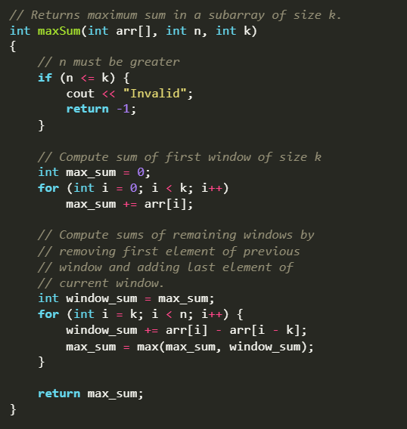
- n: This represents the size of the array, or the total number of elements in the array arr[].
- k: This is the size of the subarray (or window) that we are considering when calculating the sum of elements.
In this code, the goal is to find the maximum sum of a subarray of size k within an array of size n. The sliding window technique is used to efficiently calculate the sum of all subarrays of size k.

Maximum Sum of Subarray of Size K
- Modification: Your current code already solves this problem perfectly. It calculates the maximum sum of any subarray of size k by sliding the window and comparing sums.

2. Minimum Sum of Subarray of Size K
Modification: Instead of tracking the maximum sum, track the minimum sum in each window:
cpp
Copy code
max_sum = min(max_sum, window_sum); // Change max() to min() in the loop

- This will give you the smallest sum of a subarray of size k.

3. Longest Substring with No More Than K Distinct Characters (for strings)
- Modification:
  - Instead of using an array, use a string and a frequency map (e.g., unordered_map<char, int>) to count the occurrences of distinct characters.
  - Expand the window (right pointer) until there are more than k distinct characters.
  - Shrink the window (left pointer) when the number of distinct characters exceeds k.
  - Keep track of the maximum window size that satisfies the condition.

4. Maximum in Each Subarray of Size K
- Modification:
  - Instead of summing elements, maintain a deque that stores indices of elements in the current window in decreasing order.
  - For each window, the element at the front of the deque is the maximum.
  - Slide the window by removing elements from the front of the deque that fall out of the window and adding new elements to maintain the order.

5. Smallest Subarray with Sum Greater than or Equal to Target
- Modification:
  - Instead of fixing the window size k, expand the window (right pointer) until the sum of the current window is ≥ target.
  - Then, shrink the window (left pointer) to find the smallest subarray that satisfies the condition.
  - Track the minimum length of the window when the sum is ≥ target.

6. Longest Subarray with a Given Sum
- Modification:
  - Use a hashmap to store the sum up to the current index.
  - For each element, calculate the running sum. If (running_sum - target) exists in the hashmap, it means a subarray with the given sum exists.
  - Track the longest subarray length as you slide through the array.

Binary Search
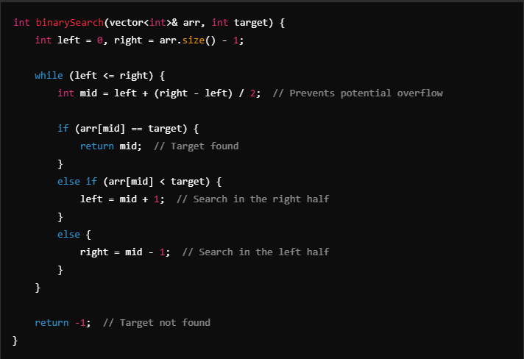

std::iota(container.begin(), container.end(), s) in numeric
Fills a container with values starting from s with an increment of 1
Knapsack:
DP[i, j] = max(v[i-1, j], v[i-1, j-weight]+profit)

IsPrime

bool isPrime(int num)
{
if (num <= 1) return false;
for (int i = 2; i * i <= num; i++)
{
if (num % i == 0) return false;
}
return true;
}

Diagonal Traversal
vector<int> findDiagonalOrder(vector<vector<int>>& mat) {
if (mat.empty() || mat[0].empty()) return {};

int m = mat.size();
int n = mat[0].size();
vector<int> result;
result.reserve(m * n);

for (int count = 0; count < m + n - 1; ++count) {
if (count % 2 == 0) {
int x = min(count, m - 1);
int y = count - x;
while (x >= 0 && y < n) {
result.push_back(mat[x][y]);
--x;
++y;
}
}
else {
int y = min(count, n - 1);
int x = count - y;
while (x < m && y >= 0) {
result.push_back(mat[x][y]);
++x;
--y;
}
}
}

return result;
}

Using lambda expression
auto cmp = [](const T& a, const T& b) { return true; };
set<T, decltype(cmp)> a_set_with_customized_comparator(cmp);
Compare function
Binary function that accepts two elements in the range as arguments, and returns a value convertible to bool. It should returns true if the first element is considered to be "smaller" than the second one.
Using by sort, make_heap and etc.
bool myfunction (int i,int j) { return (i<j); }
Define operator <()
Member function
recommended // can use for priority_queue, sort,
struct Edge {
int from, to, weight;
bool operator<(Edge that) const {
return weight > that.weight;
}
};

Define operator()()
You can use comparison function for STL containers by passing them as the first argument of the constructor, and specifying the function type as the additional template argument. For example:
set<int, bool (*)(int, int)> s(cmp);
A functor, or a function object, is an object that can behave like a function. This is done by defining operator()() of the class. In this case, implement operator()() as a comparison function:
vector<int> occurrences;
struct cmp {
bool operator()(int a, int b) {
return occurrences[a] < occurrences[b];
}
};
set<int, cmp> s;
priority_queue<int, vector<int>, cmp> pq;
Used by priority_queue .
1.3.8 Custom Sort Function for Set and Priority Queue
** set **

auto cmp = [](int a, int b) { return ... };
// auto cmp = [](const int& a, const int& b) { return ... };
std::set<int, decltype(cmp)> s(cmp);

** priority_queue **

auto cmp = [](int a, int b) { return ... };
// auto cmp = [](const int& a, const int& b) { return ... };
priority_queue<int, vector<int>, decltype(cmp)> pq(cmp);

—------------------
Sorting Algorithms:

void selectionSort(std::vector<int>& arr) {
int n = arr.size();
for (int i = 0; i < n - 1; ++i) {
int minIndex = i;
for (int j = i + 1; j < n; ++j) {
if (arr[j] < arr[minIndex])
minIndex = j;
}
std::swap(arr[i], arr[minIndex]); // Swap the found minimum element
}
}
—---------------------------------
void insertionSort(std::vector<int>& arr) {
int n = arr.size();
for (int i = 1; i < n; ++i) {
int key = arr[i];
int j = i - 1;
while (j >= 0 && arr[j] > key) {
arr[j + 1] = arr[j];
--j;
}
arr[j + 1] = key; // Place the key at its correct position
}
}

—-----------------------------------
void bubbleSort(std::vector<int>& arr) {
int n = arr.size();
bool swapped;
for (int i = 0; i < n - 1; ++i) {
swapped = false;
for (int j = 0; j < n - i - 1; ++j) {
if (arr[j] > arr[j + 1]) {
std::swap(arr[j], arr[j + 1]);
swapped = true;
}
}
if (!swapped) break; // If no two elements were swapped, array is sorted
}
}

—---------------------------------

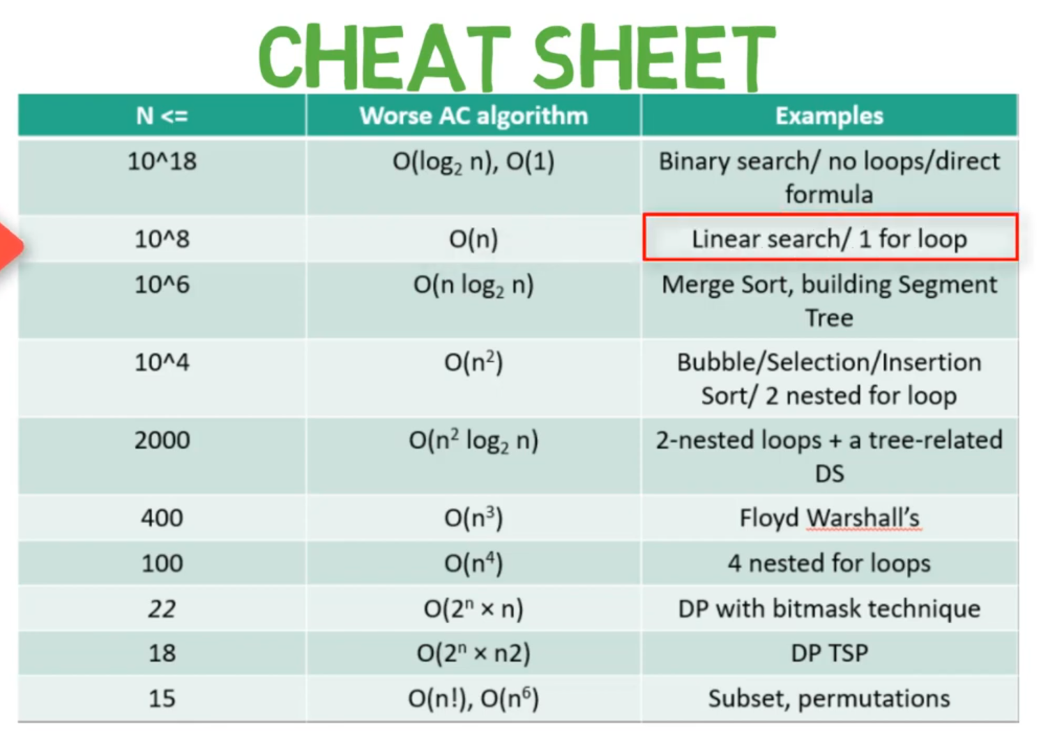

ios::sync_with_stdio(false); // brains
cin.tie(nullptr); // Optional: It unties cin from cout, improving I/O speed
Cin >> noskipws

CHRONO s

#include <iostream>
#include <chrono>

int main() {
// 1. Start Time
auto start = std::chrono::high_resolution_clock::now();

// 2. Code Block
// Insert the code you want to time here

// 3. End Time
auto end = std::chrono::high_resolution_clock::now();

// 4. Duration Calculation
auto duration = std::chrono::duration_cast<std::chrono::milliseconds>(end - start).count();

std::cout << "Duration: " << duration << " milliseconds." << std::endl;
return 0;
}

Chrono:
1s == 10^8 operations

N > 10^8 O( logn ) N < 10^8 O( n )
N < 10^6 O( nlogn ) N < 10^4 O( n^2 )
N < 500 O( n^3 ) N < 25 O( 2^n ) N < 12 O( n! )

<chrono>
auto start = std::chrono::high_resolution_clock::now();
auto stop = std::chrono::high_resolution_clock::now();
auto duration = std::chrono::duration_cast<std::chrono::microseconds>(stop - start);
std::cout << "Time taken: " << duration.count() << " microseconds" << std::endl;

